**Name: Shivam Tiwari**

**Roll no : 5117060**

**EXPERIMENT 02**

**Aim**: To implement RMI using java

**Theory:**

* RPC mechanism uses the concepts of stubs to achieve the goal of semantic transparency.
* Stubs provide a local procedure call abstraction by concealing the underlying RPC mechanism.
* A separate stub procedure is associated with both the client and server processes.
* RPC communication package known as RPC Runtime is used on both the sides to hide existence and functionalities of a network.
* Thus, implementation of RPC involves the five elements of program:
  + Client
  + Client Stub
  + RPC Runtime
  + Server stub
  + Server

The client, the client stub, and one instance of RPC Run time execute on the client machine. The server, the server stub, and one instance of RPC Run time execute on the server machine. Remote services are accessed by the user by making ordinary LPC.

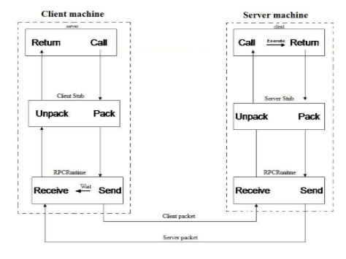

**1. Client**

* A Client is a user process which initiates a RPC
* The client makes a normal call that will invoke a corresponding procedure in the client stub.

**2. Client Stub**

Client stub is responsible for the following two tasks:

1. On receipt of a call request from the client, it packs specifications of the target procedure and arguments into a message and asks the local RPCRuntime to send it to the server stub.
2. On receipt of the result of procedure execution, it unpacks the result and passes it to the client.

**3. RPCRuntime**

* Transmission of messages between Client and the server machine across the network is handled by RPCRuntime.
* It performs Retransmission, Acknowledgement, Routing and Encryption.
* RPCRuntime on Client machine receives messages containing result of procedure execution from server and sends it client stub as well as the RPCRuntime on server machine receives the same message from server stub and passes it to client machine.
* It also receives call request messages from client machine and sends it to server stub.

**4. Server Stub**

Server stub is similar to client stub and is responsible for the following two tasks:

i. On receipt of a call request message from the local RPCRuntime, it unpacks and makes a normal call to invoke the required procedure in the server.

ii. On receipt of the result of procedure execution from the server, it unpacks the result into a message and then asks the local RPCRuntime to send it to the client stub.

**5. Server**

When a call request is received from the server stub, the server executes the required procedure and returns the result to the server stub.

**RMI:**

Server Side:

* Create a remote interface. (myInterface.java)
* Create a separate java file to implement the remote interface. (RMIServer.java)
* Register the interface in RMI registry (bind with any name eg: myRMIService)

Client Side:

* In client code, through interface name (in our case myRMIService) create a "fake remote" object reference of server within client. (RMIClient.java)
* Through this reference access the server methods / services

**CODE:**

**. MyInterface.java**

1. import java.rmi.*;
2. public interface **MyInterface** extends Remote
3. {
4. public String countInput(String input)throws RemoteException;
5. }

**2. RMIServer.java**

1. import java.rmi.*;
2. import java.rmi.server.*;
3. public class **RMIServer** extends UnicastRemoteObject implements MyInterface
4. {
5. public RMIServer()throws RemoteException
6. {
7. System.out.println("Remote Server is running Now.!!");
8. }
9. public static void main(String arg[])
10. {
11. try{
12. RMIServer p=new RMIServer();
13. Naming.rebind("rmiInterface",p);
14. }
15. catch(Exception e)
16. { System.out.println("Exception occurred : "+e.getMessage()); }
17. }
18. @Override
19. public String countInput(String input) throws RemoteException
20. {
21. System.out.println("Received your input "+ input+" at server!!");
22. String reply;
23. reply="You have typed "+ input.length() +" letters!!";
24. return reply;
25. }
26. }

**3. RMIClient.java**

1. import java.rmi.*;
2. import java.io.*;
3. public class RMIClient
4. {
5. public static void main(String args[])
6. {
7. try
8. { BufferedReader br=new BufferedReader(new InputStreamReader(System.in));
9. MyInterface p=( MyInterface)Naming.lookup("rmiInterface");
10. System.out.println("Type something...");
11. String input=br.readLine();
12. System.out.println(p.countInput(input));
13. }
14. catch(Exception e) {
15. System.out.println("Exception occurred : "+e.getMessage());
16. }
17. }
18. }

**RESULT:**

Compile the java files.

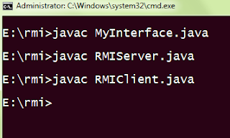

Run remote object registry called rmiregistry. It is used by RMI servers on the same host to bind remote objects to names.

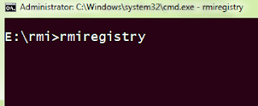

Run the Server class.

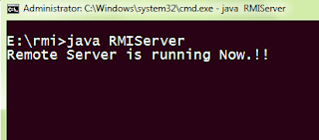

Run the client class. You can see it is prompting for input

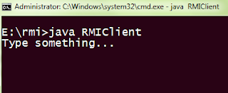

Type some text

Input is received by remote server

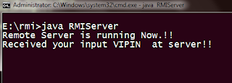

Client receives reply from remote server

